Modifier

🔹 What is Modifier
# Source: AI Source: Provided by: [Data Path: Persons Table -> ID Column: 1, Name_En Column: Motasem Essam] -> From: [Chatgpt (GPT-4-turbo)] on [8/3/2025]
A modifier is a word, phrase, or clause that describes, limits, or adds detail to another word (usually a noun or verb).
Modifiers provide extra information about the word they modify, and they can appear before or after the word.
🧠 A modifier “modifies” (changes or sharpens) the meaning of another word or phrase.

✅ Key Characteristics of Modifiers:
# Source: AI Source: Provided by: [Data Path: Persons Table -> ID Column: 1, Name_En Column: Motasem Essam] -> From: [Chatgpt (GPT-4-turbo)] on [8/3/2025]
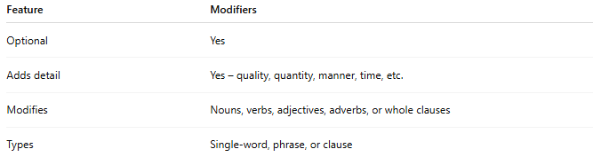
Feature | Modifiers
Optional | Yes
Adds detail | Yes – quality, quantity, manner, time, etc.
Modifies | Nouns, verbs, adjectives, adverbs, or whole clauses
Types | Single-word, phrase, or clause

✅ Main Types of Modifiers:
# Source: AI Source: Provided by: [Data Path: Persons Table -> ID Column: 1, Name_En Column: Motasem Essam] -> From: [Chatgpt (GPT-4-turbo)] on [8/3/2025]
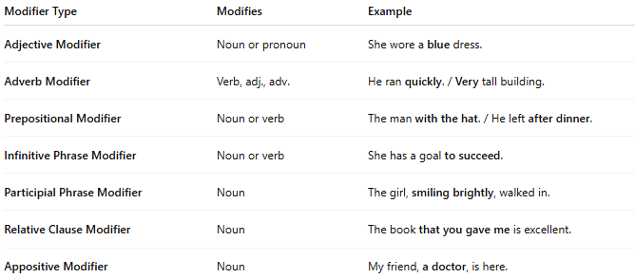
Modifier Type | Modifies | Example
Adjective Modifier | Noun or pronoun | She wore a blue dress.
Adverb Modifier | Verb, adj., adv. | He ran quickly. / Very tall building.
Prepositional Modifier | Noun or verb | The man with the hat. / He left after dinner.
Infinitive Phrase Modifier | Noun or verb | She has a goal to succeed.
Participial Phrase Modifier | Noun | The girl, smiling brightly, walked in.
Relative Clause Modifier | Noun | The book that you gave me is excellent.
Appositive Modifier | Noun | My friend, a doctor, is here.

✅ Position of Modifiers:
# Source: AI Source: Provided by: [Data Path: Persons Table -> ID Column: 1, Name_En Column: Motasem Essam] -> From: [Chatgpt (GPT-4-turbo)] on [8/3/2025]
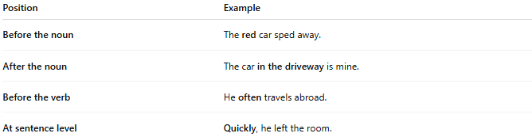
Position | Example
Before the noun | The red car sped away.
After the noun | The car in the driveway is mine.
Before the verb | He often travels abroad.
At sentence level | Quickly, he left the room.

✅ Dangling and Misplaced Modifiers:
# Source: AI Source: Provided by: [Data Path: Persons Table -> ID Column: 1, Name_En Column: Motasem Essam] -> From: [Chatgpt (GPT-4-turbo)] on [8/3/2025]
- Misplaced Modifier: Incorrectly placed, causing confusion.
❌ She served sandwiches to the children on paper plates.
✅ She served the children sandwiches on paper plates.
- Dangling Modifier: No clear subject being modified.
❌ Walking to the store, the rain started.
✅ While I was walking to the store, the rain started.

✅ Modifier vs. Complement:
# Source: AI Source: Provided by: [Data Path: Persons Table -> ID Column: 1, Name_En Column: Motasem Essam] -> From: [Chatgpt (GPT-4-turbo)] on [8/3/2025]
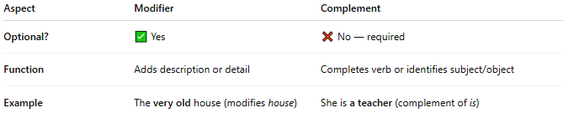
Aspect | Modifier | Complement
Optional? | ✅ Yes | ❌ No — required
Function | Adds description or detail | Completes verb or identifies subject/object
Example | The very old house (modifies house) | She is a teacher (complement of is)

✅ Summary:
# Source: AI Source: Provided by: [Data Path: Persons Table -> ID Column: 1, Name_En Column: Motasem Essam] -> From: [Chatgpt (GPT-4-turbo)] on [8/3/2025]
- A modifier enhances the meaning of another element in a sentence.
- Types include adjectives, adverbs, phrases, and clauses.
- Modifiers are optional, and correct placement is essential for clarity.
- Always check for dangling or misplaced modifiers in writing.

